Testing, QA and QC

Testing
# Source: AI Source: Provided by: [Data Path: Persons Table -> ID Column: 1, Name_En Column: Motasem Essam] -> From: [Chatgpt (GPT‑5 Mini)] on [8/22/2025]
- Meaning: The process of executing software to find defects and verify it works as expected.
- Focus: Detect problems in the product.
- Scope: Narrow — part of the QA process.
- Goal: Identify bugs.
- Who does it: Testers / QA engineers.
- Example: Running a login test case to see if the user can log in successfully.

QA – Quality Assurance
# Source: AI Source: Provided by: [Data Path: Persons Table -> ID Column: 1, Name_En Column: Motasem Essam] -> From: [Chatgpt (GPT‑5 Mini)] on [8/22/2025]
- Meaning: A process-oriented approach that ensures the methods, standards, and procedures used during development will result in a quality product.
- Goal: Prevent defects.
- Focus: Improving and controlling how the product is built.
- Timing: Throughout the Software Development Life Cycle (SDLC).
- Example:
  - Defining coding standards.
  - Setting up review checklists.
  - Choosing a testing strategy before development starts.

💡 Simple example:
- Requirements phase: QA checks that requirements are clear, consistent, and testable.
- Design phase: QA ensures design follows best practices and standards.
- Development phase: QA confirms coding standards, reviews, and processes are followed.
- Testing and release: QA verifies that testing procedures meet quality criteria.

Key Difference Table
# Source: AI Source: Provided by: [Data Path: Persons Table -> ID Column: 1, Name_En Column: Motasem Essam] -> From: [Chatgpt (GPT‑5 Mini)] on [8/22/2025]
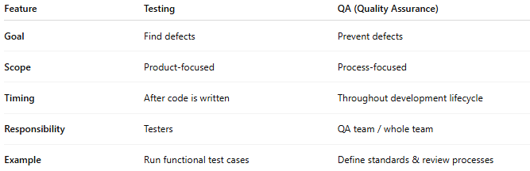
Feature | Testing | QA (Quality Assurance)
Goal | Find defects | Prevent defects
Scope | Product-focused | Process-focused
Timing | After code is written | Throughout development lifecycle
Responsibility | Testers | QA team / whole team
Example | Run functional test cases | Define standards & review processes

💡 In short:
- Testing = Checking the product.
- QA = Ensuring the process makes a good product.

QC – Quality Control
# Source: AI Source: Provided by: [Data Path: Persons Table -> ID Column: 1, Name_En Column: Motasem Essam] -> From: [Chatgpt (GPT‑5 Mini)] on [8/22/2025]
- Meaning: A product-oriented approach that checks the actual product to ensure it meets requirements and is free of defects.
- Goal: Detect defects.
- Focus: Inspecting and testing the finished product.
- Timing: After the product (or part of it) is built.
- Example:
  - Running functional tests.
  - Performing UI checks.
  - Measuring performance.

Key Difference Table
# Source: AI Source: Provided by: [Data Path: Persons Table -> ID Column: 1, Name_En Column: Motasem Essam] -> From: [Chatgpt (GPT‑5 Mini)] on [8/22/2025]
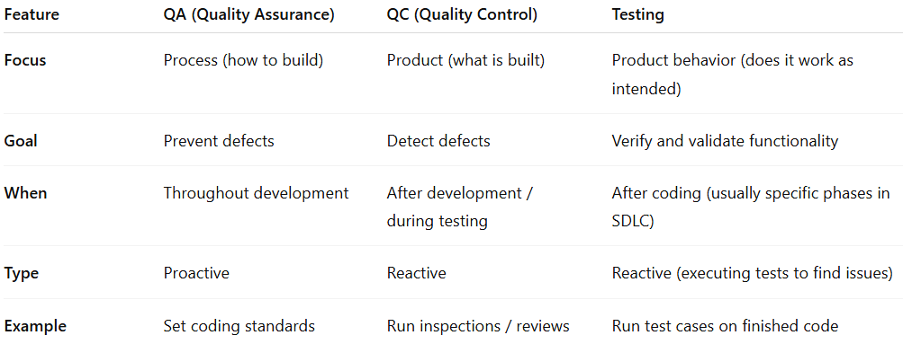

Feature | QA (Quality Assurance) | QC (Quality Control) | Testing
Focus | Process (how to build) | Product (what is built) | Product behavior (does it work as intended)
Goal | Prevent defects | Detect defects | Verify and validate functionality
When | Throughout development | After development / during testing | After coding (usually specific phases in SDLC)
Type | Proactive | Reactive | Reactive (executing tests to find issues)
Example | Set coding standards | Run inspections / reviews | Run test cases on finished code

💡 In short:
- QA = Make sure the recipe for making the cake is correct and followed.
- QC = Taste and inspect the cake to see if it’s good.

Relation of testing for QA and QC
# Source: AI Source: Provided by: [Data Path: Persons Table -> ID Column: 1, Name_En Column: Motasem Essam] -> From: [Chatgpt (GPT‑5 Mini)] on [8/22/2025]
Alright — here’s how testing connects to QA and QC:

1. QA (Quality Assurance) & Testing
# Source: AI Source: Provided by: [Data Path: Persons Table -> ID Column: 1, Name_En Column: Motasem Essam] -> From: [Chatgpt (GPT‑5 Mini)] on [8/22/2025]
- Relation: Testing is one of the activities inside QA, but QA is much bigger.
- QA sets the processes, standards, and plans for testing.
- Without QA → testing may be unorganized or miss important areas.
- Example:
  - QA defines that “all features must have automated regression tests.”
  - Testing team follows that rule and runs the tests.

2. QC (Quality Control) & Testing
# Source: AI Source: Provided by: [Data Path: Persons Table -> ID Column: 1, Name_En Column: Motasem Essam] -> From: [Chatgpt (GPT‑5 Mini)] on [8/22/2025]
- Relation: Testing is a main tool used in QC to check the product for defects.
- QC focuses directly on the product quality, and testing is how we inspect that.
- Without testing → QC has no way to confirm if the product works correctly.
- Example:
  - QC checks the login feature by executing test cases.
  - If a bug is found, it’s reported for fixing.

Putting It Together Visually
# Source: AI Source: Provided by: [Data Path: Persons Table -> ID Column: 1, Name_En Column: Motasem Essam] -> From: [Chatgpt (GPT‑5 Mini)] on [8/22/2025]
- QA → Big umbrella covering all quality processes (includes planning testing).
- QC → Hands-on product checking (mainly done through testing).
- Testing → The actual execution of checks, part of both QA and QC, but for different purposes:
  - In QA, it’s to confirm the process works.
  - In QC, it’s to confirm the product works.

💡 Simple analogy:
- QA = Planning how to make a safe car.
- QC = Inspecting the finished car.
- Testing = Driving the car to see if it runs well.

